Big O ist worse case time complexity

Big Omega is best case time complexity

Big Theta if the runtime is the same in every case:

Calculating the average runtime for linear search (from Codecademy): I WANT THE MATH!

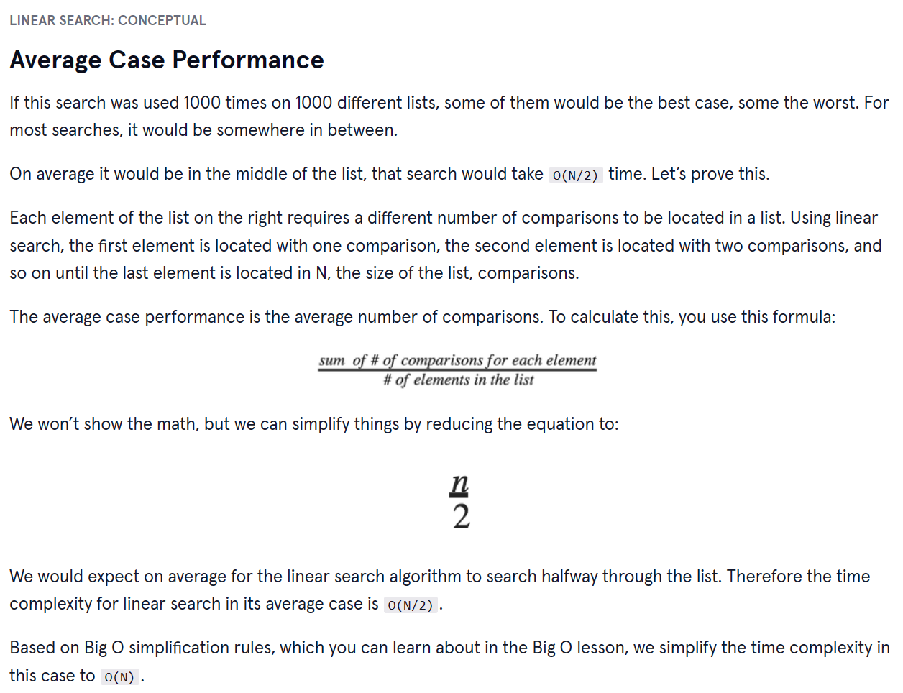

Linear Search is useful when:

* Working with unsorted lists
* You expect to find an element in the beginning of a list
* Find duplicates
* Find maximum value